Excel Community School
Content Management System/Backend Administrator Guide
The admin page is, by design, not public facing. There is no visible link on the website to it.
To access admin functions go to:
/admin/login
Admin Username: 4dministr80r@excels.edu.gh
Admin Password: Nimda$Excel321!
Upon login, you’ll be redirected to the Admin Dashboard where you’ll get an overview and details of Appointment Bookings.
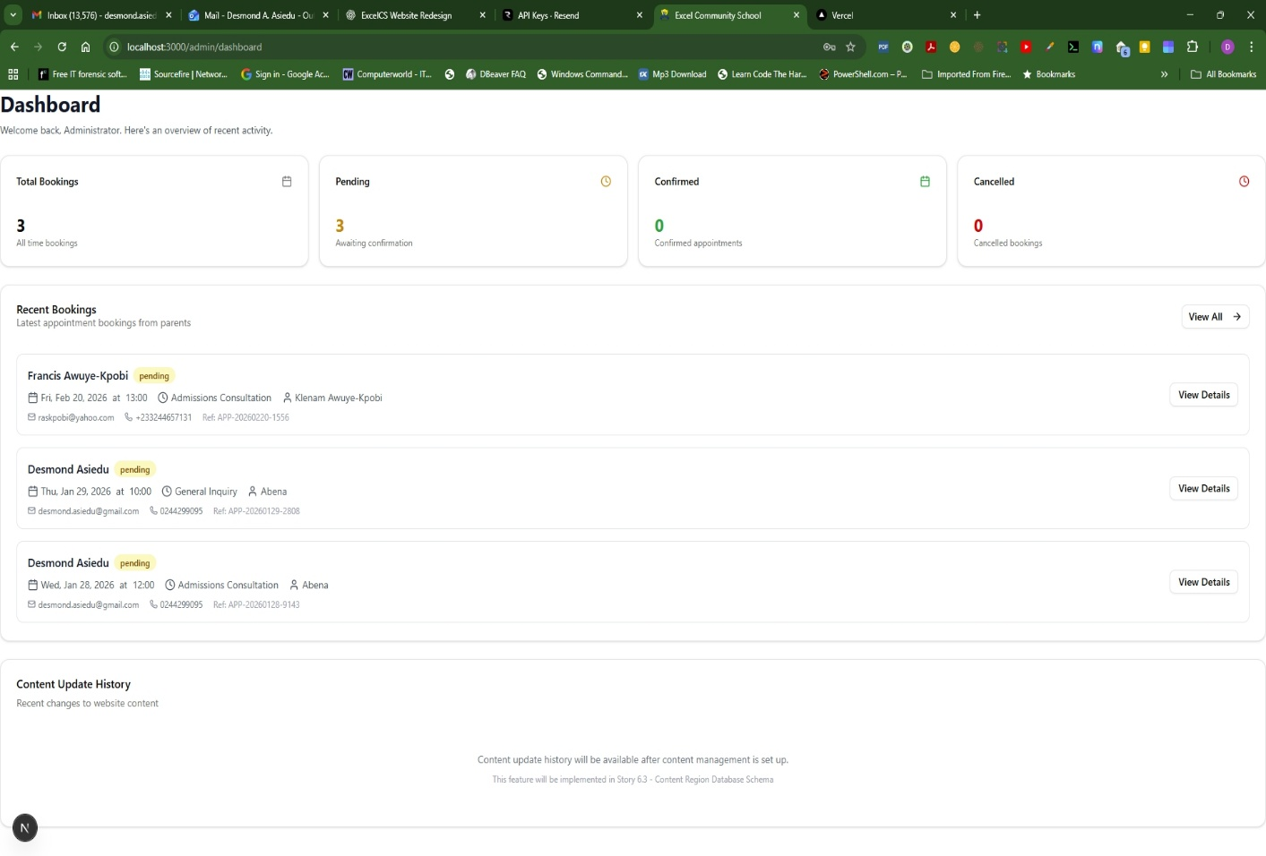
To access the content management engine:
/admin/content
Choose an editable content area and click on “Edit Content” to update/edit the content for that area/region (highlighted in red).
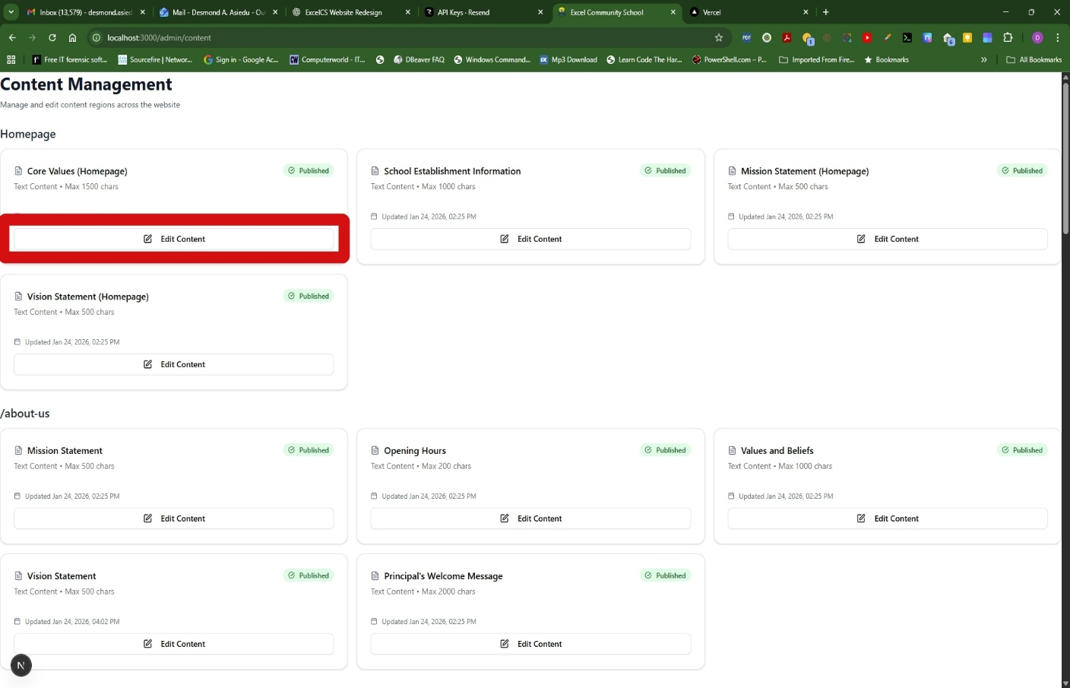
Click “Publish” to complete the edit.
To edit Images in the Gallery, do to /admin/images
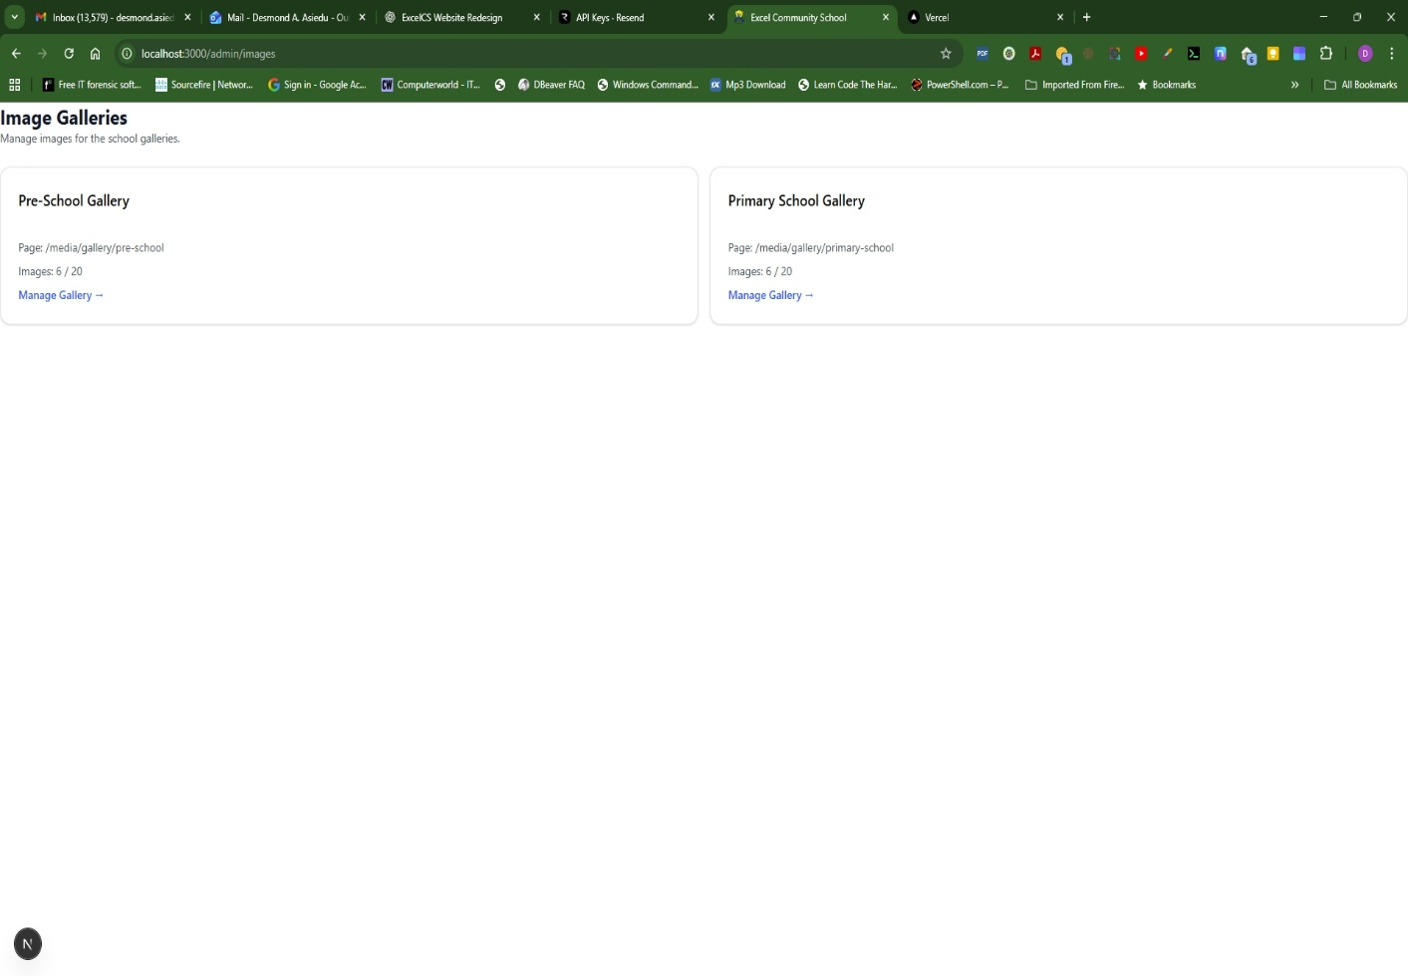
Select/Click the gallery you want to update
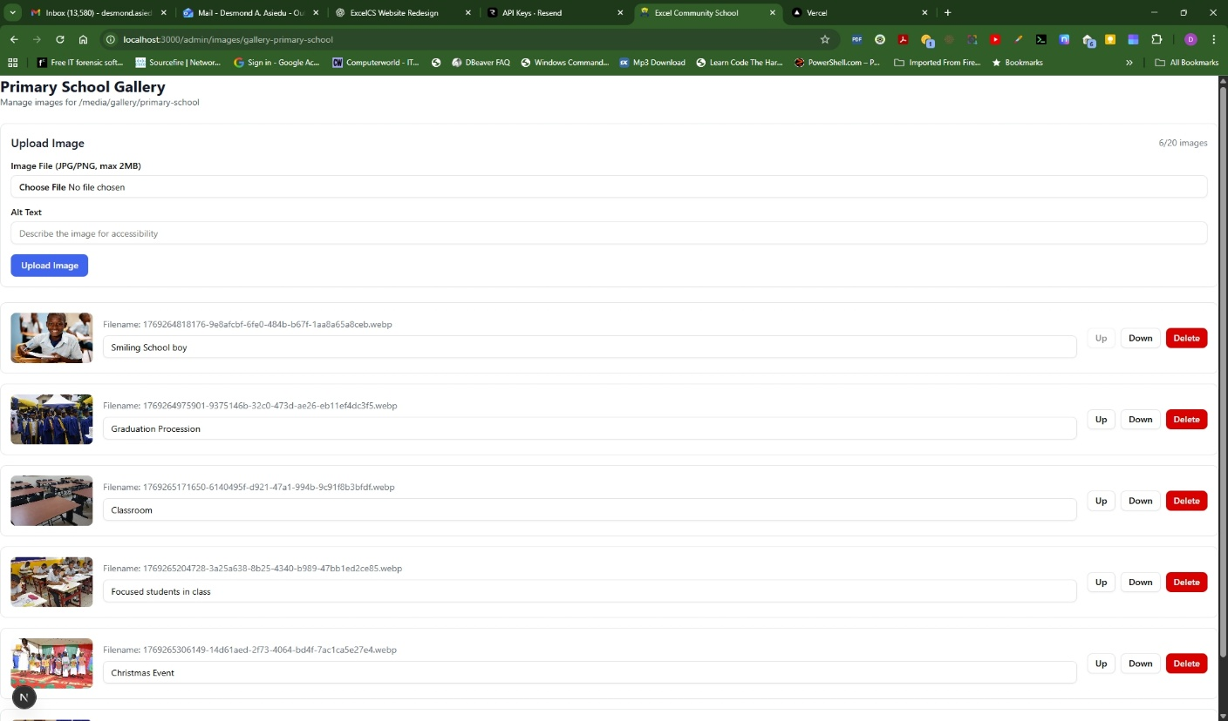
Click on “Choose File” and navigate to the folder where your images are located.
Add Accessibility text (caption) and click on the “Upload Image” button.
To manage bookings, go to /admin/bookings
Here you can:
View, confirm, or cancel parent appointments and add internal notes.

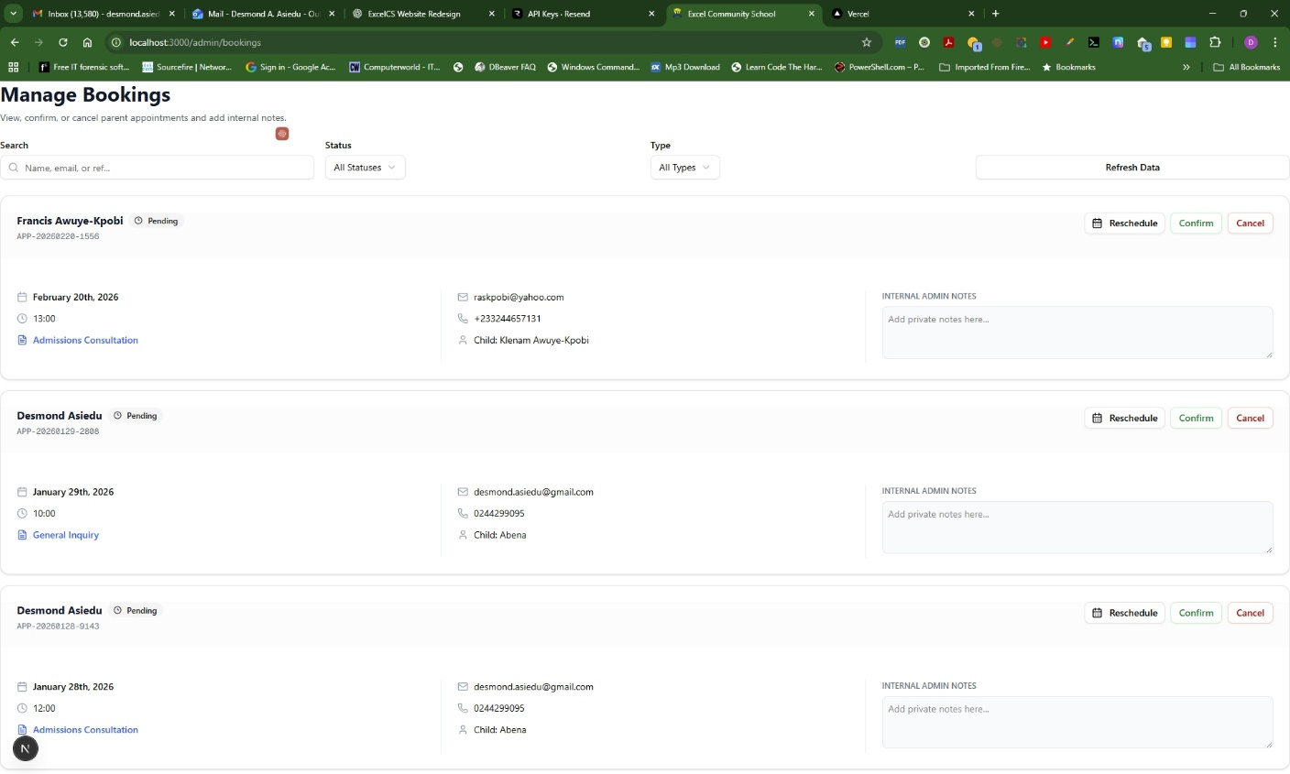

To manage booking availability, go to /admin/availability
Here you can control when parents can book appointments. Set specific time slots as available or block entire days.
